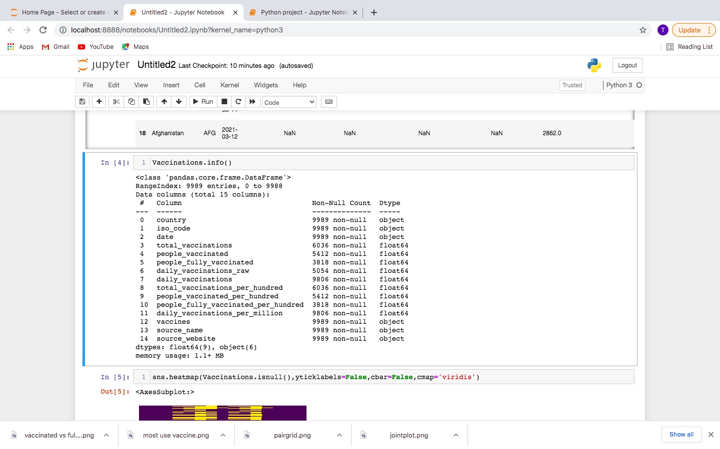

**#Importing different libraries** for linear algebra (Numpy), advanced featured excel(pandas), 2D plotting of figures(Matplotlib) and high level interface for statistical graphics (Seaborn).

**#Importing data**

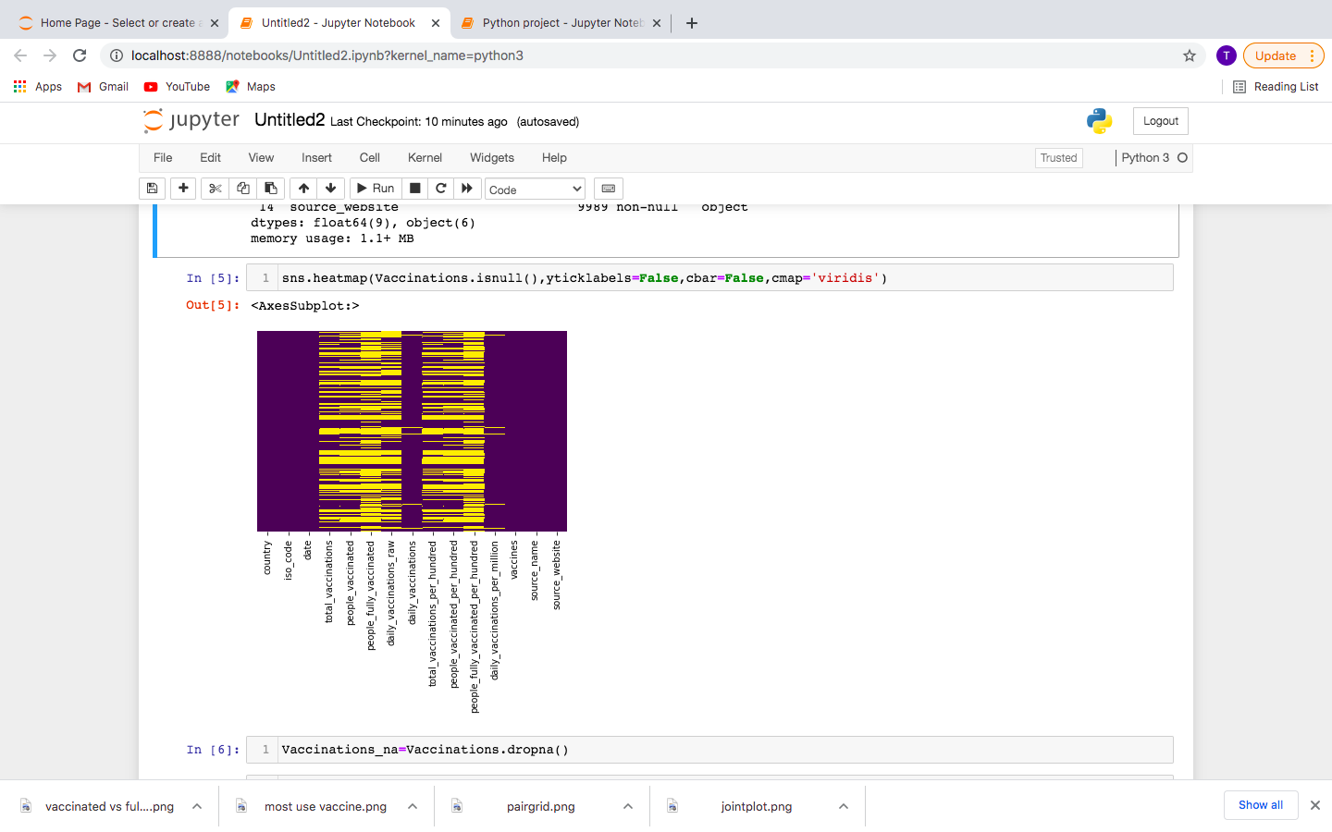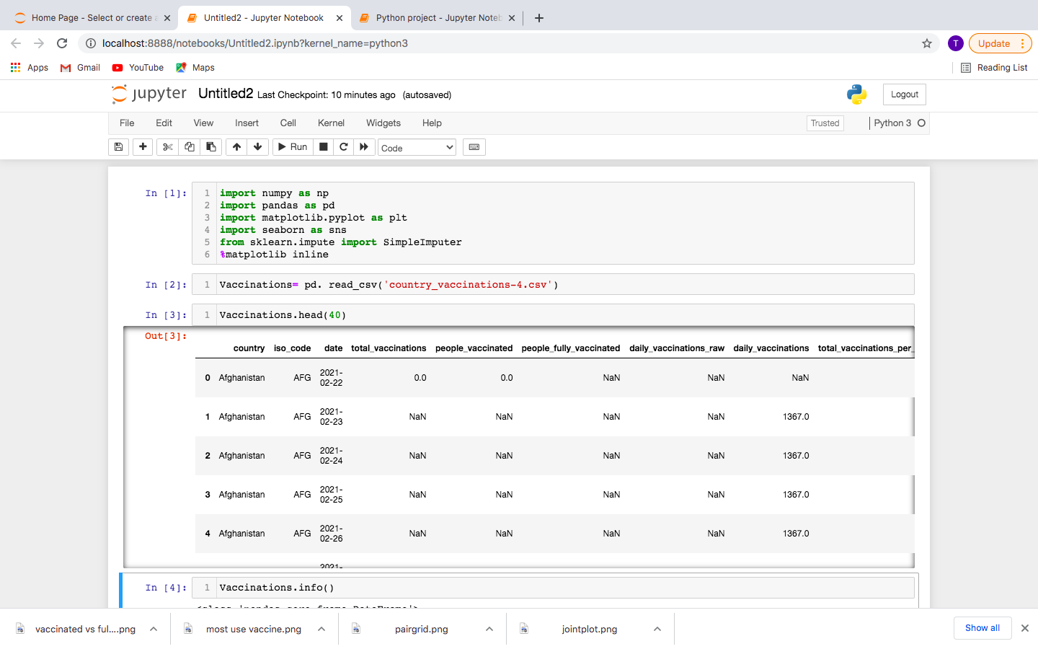

**#Finding Missing values** - single-line code of heatmap by seaborn will visualize the location of missing values. We can see decide to drop columns that have maximum values and delete the rows of the columns that are vital for analysis.

**#Exploratory Data Analysis-** used to get a concise summary of the dataframe.

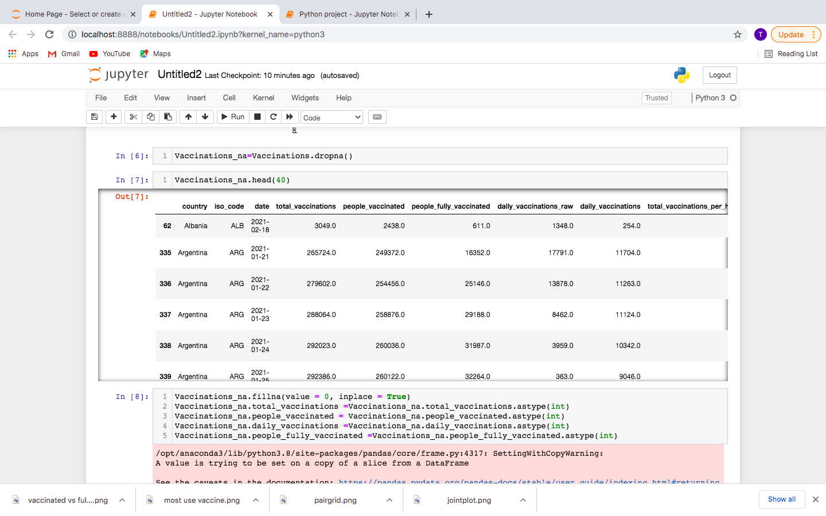

**#Converting to a specified datatype-** casting pandas objects to integer to perform operations during analysis

**#Remove missing values-** this will remove the dataframes that have null values

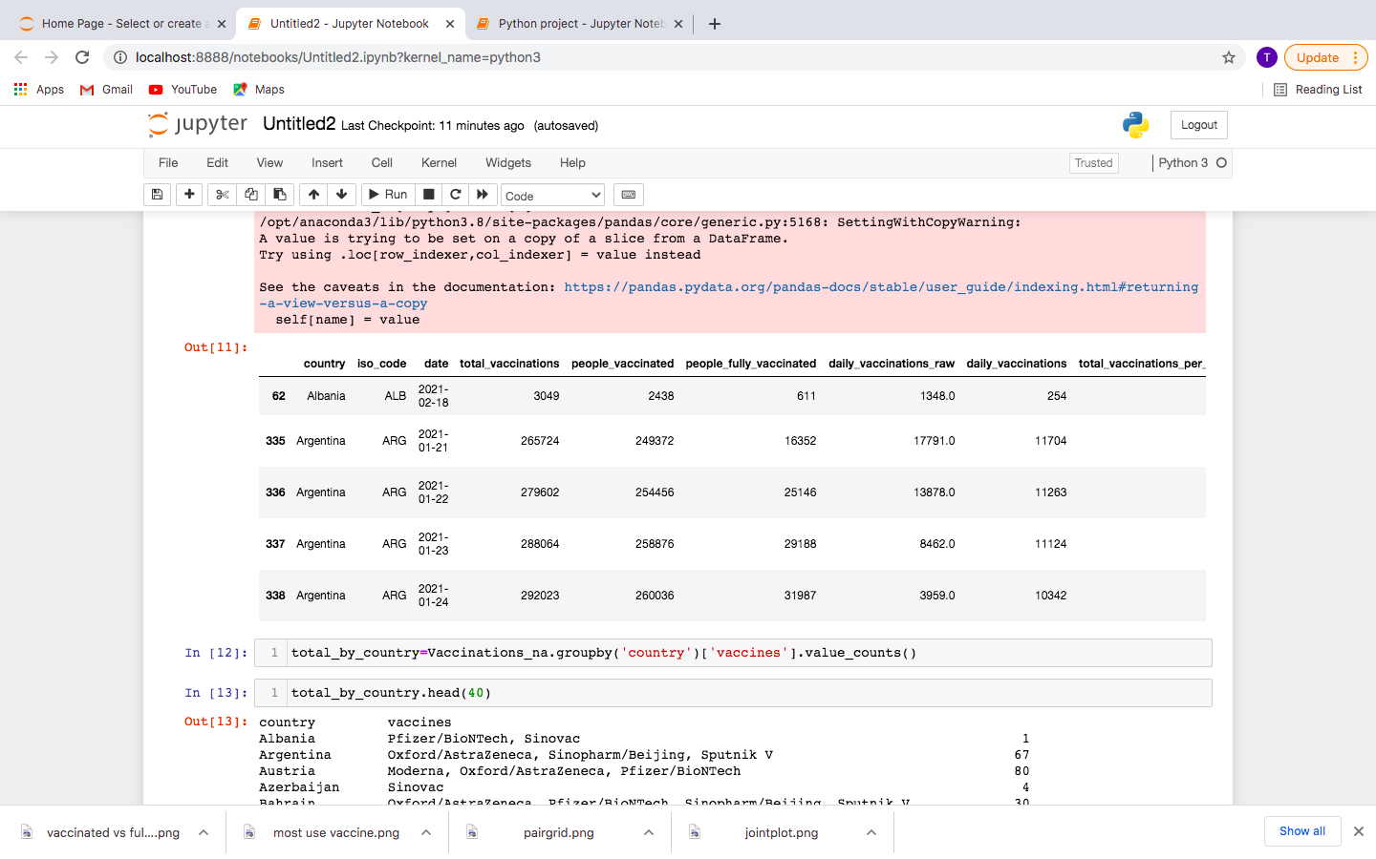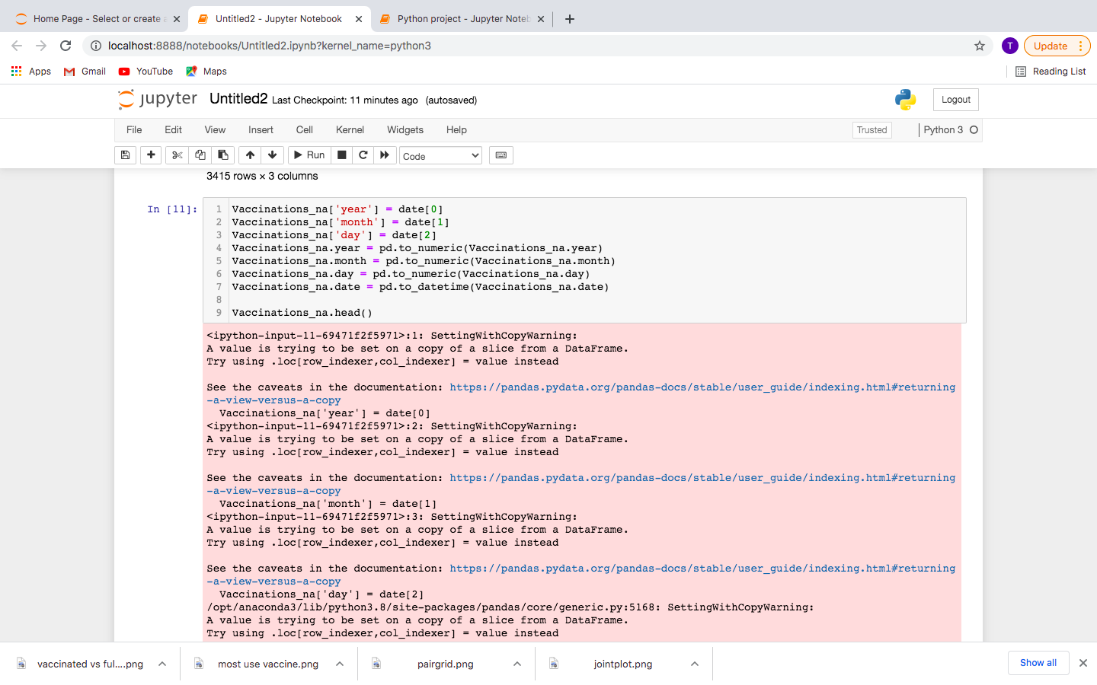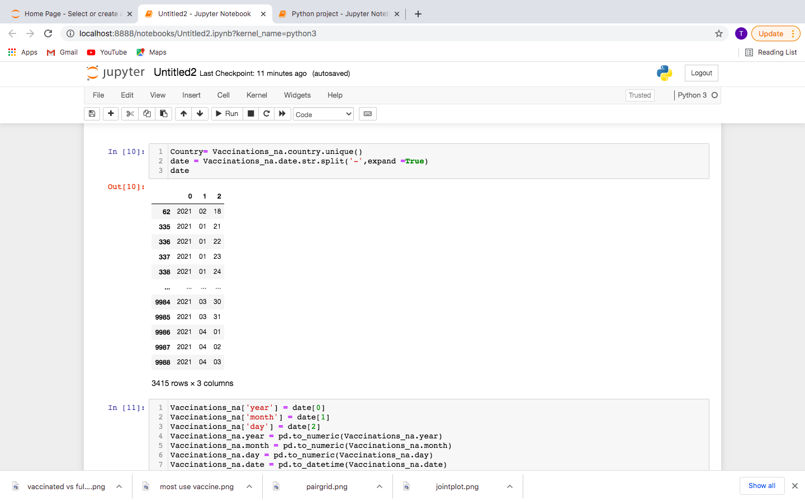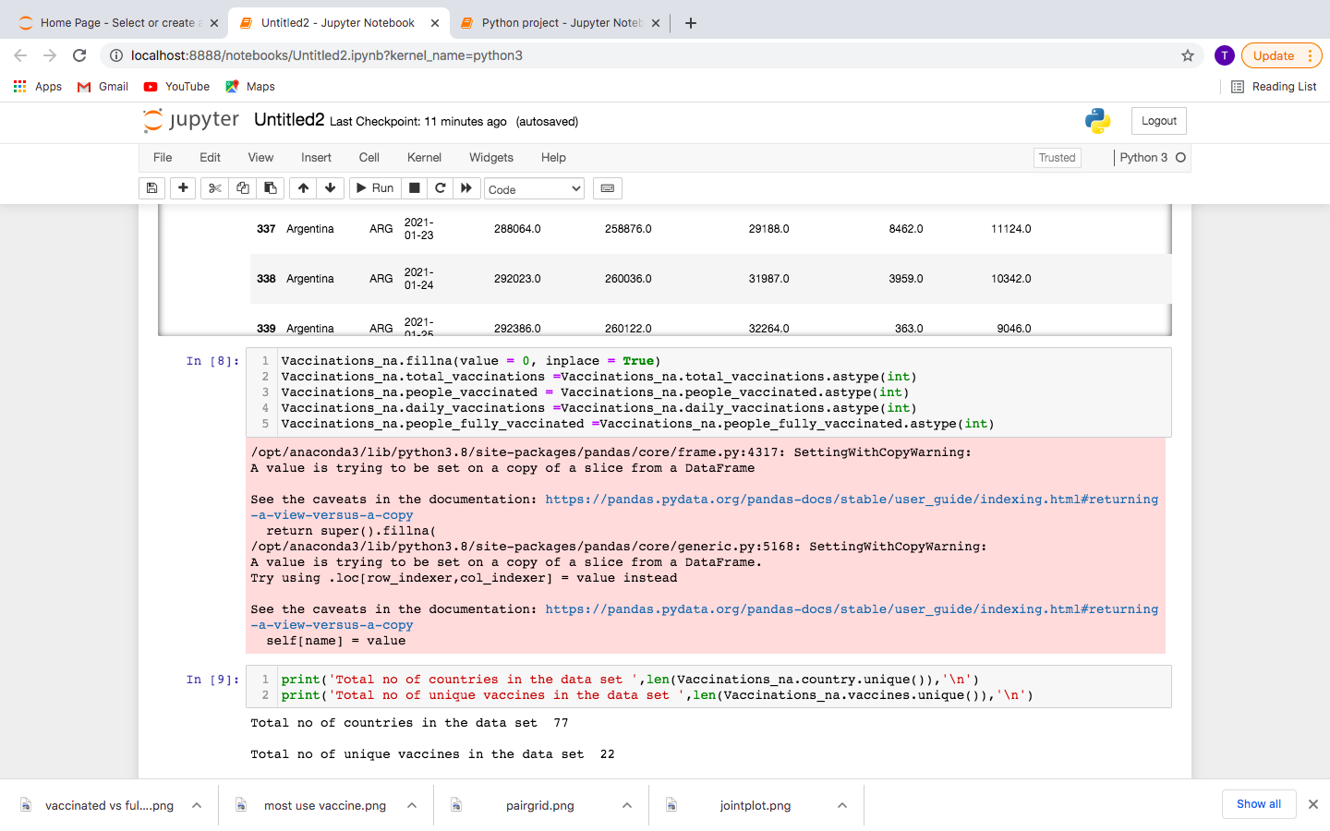

**#Formatting the Date** by the year-month-day format

**#Obtaining a unique list** -countries and types of vaccines to sort multiple entries

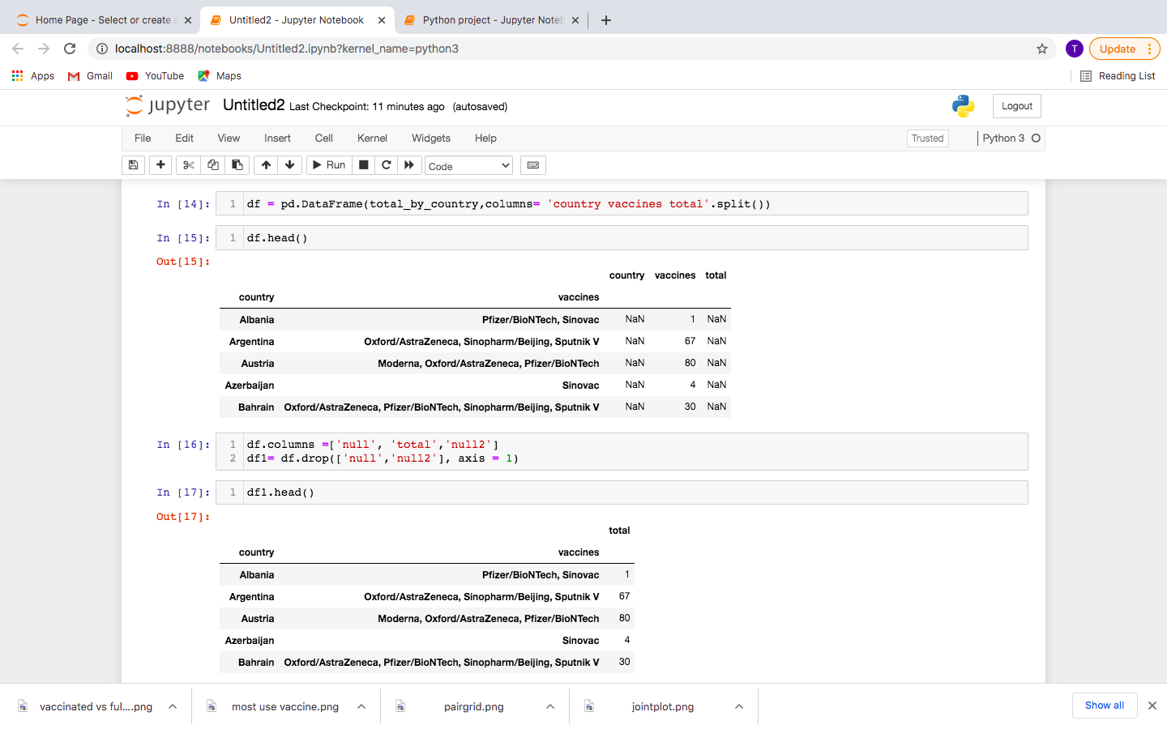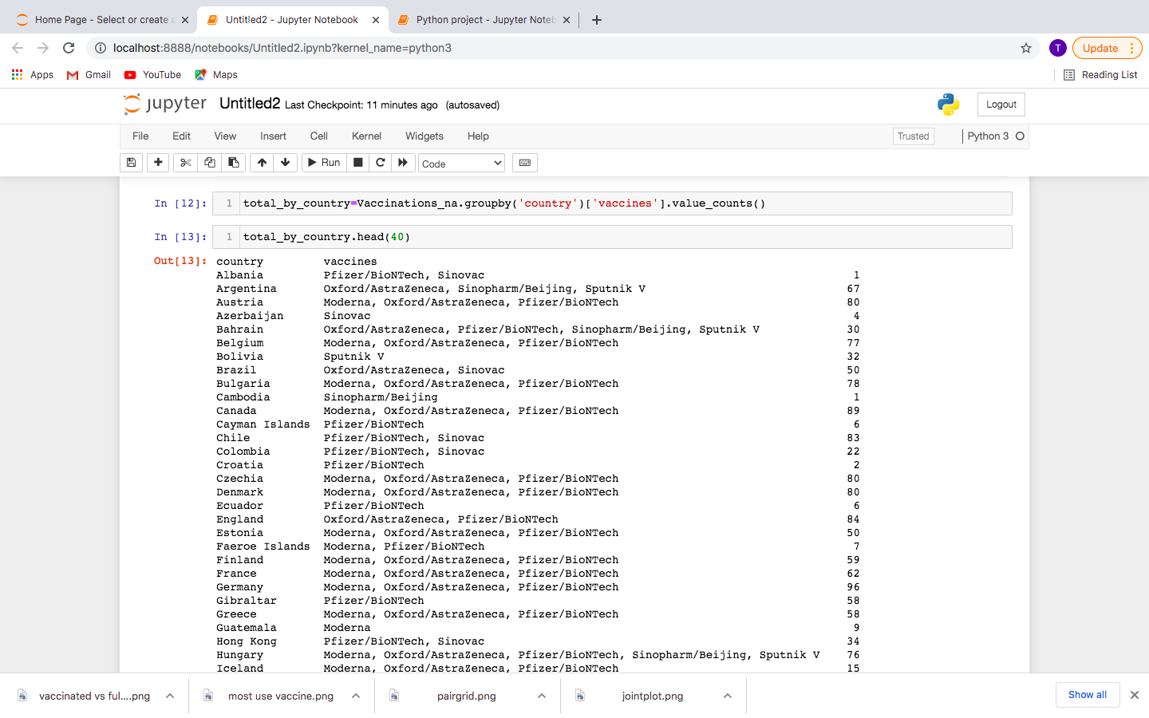

**#Grouping** countries and vaccines to get a head count for the usage of vaccines country wise

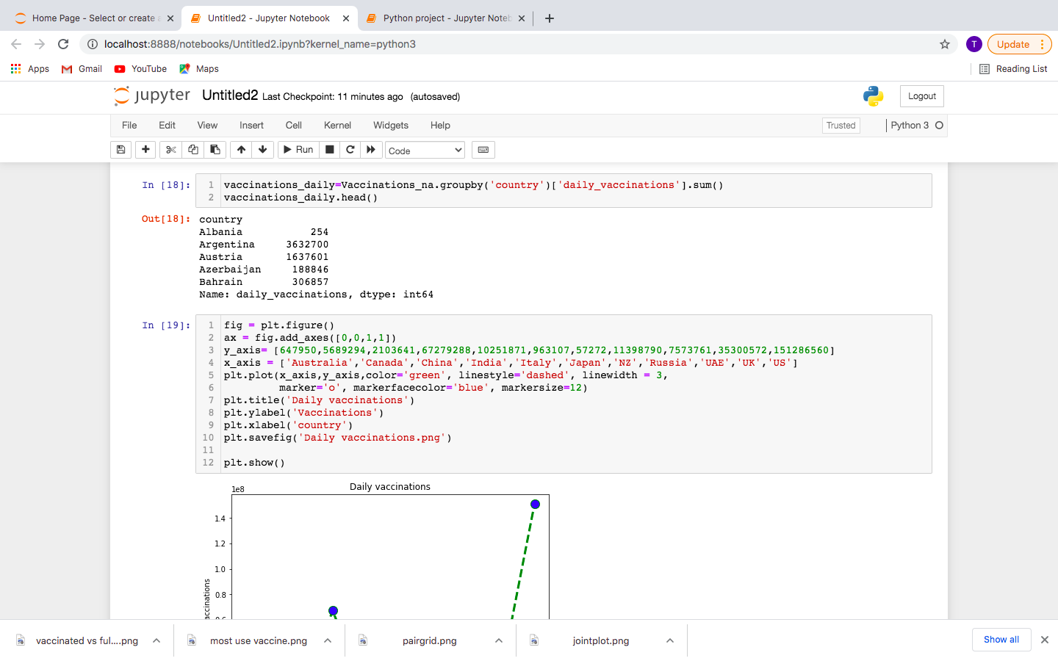

**#Grouping** countries and daily vaccinations given country wise

**#Find the top 25% of the countries** with maximum dosages given for daily vaccinations, people vaccinated and people fully vaccinated and plotting a combined graph of people vaccinated Vs people fully vaccinated

**#Plotting a line graph**

**#Creating a table** and removing the null values (columns)

